**World of Bats - Processing**

**Overview**

The aim of this workshop is to create an artificially-intelligent bat that is able to efficiently hunt down and catch food (flying insects). You will first get the opportunity to customise the appearance of your bat. Then follows a period of experimentation where you will incrementally adapt your bat’s behaviour in order to identify the most efficient and effective hunting strategy.

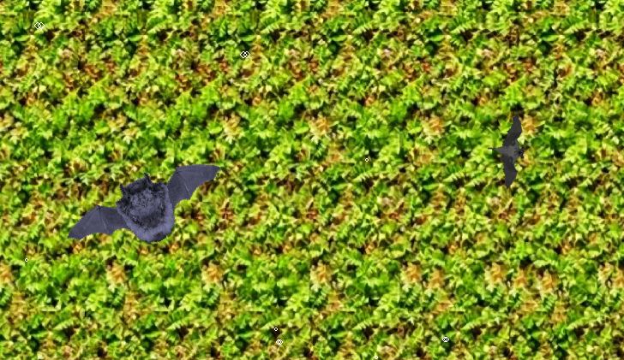

**Task 1**

The Processing project that you have been given implements a simulation of a bat world. We can add any number of different bats to the world in order to see how their hunting performance compares.

Your first task is to create a bat of your own. Open up the “WorldOfBats” folder and copy the “SimonBat” file – give the duplicate file a unique name (for example own name or a character from a film). Make sure you don’t use any spaces or unusual characters in the filename (or WorldOfBats will not be able to load the file). Open up the renamed file in Processing and change the class name of your bat file to match the filename (i.e. edit the line class SimonBat extends Bat replacing SimonBat with the unique name of your bat).

Your next task is to edit the initialiseAppearance method in order to describe your bat. First of all, describe the appearance of your bat by calling the following methods…

**setWingAppearance** – This takes a binary string that describes your bat’s wings. The first four bits are the size of the wings (from 0000 to 1111) and the last four bits are the “style” of the wings:

|  |  |
| --- | --- |
| 0000 | \\ads.bris.ac.uk\filestore\myfiles\Staff12\sl17668\Documents\Work\Teaching\Workshops\WorldOfBats\Images\Wings\0000.png |
| 0001 | \\ads.bris.ac.uk\filestore\myfiles\Staff12\sl17668\Documents\Work\Teaching\Workshops\WorldOfBats\Images\Wings\0001.png |
| 0010 | \\ads.bris.ac.uk\filestore\myfiles\Staff12\sl17668\Documents\Work\Teaching\Workshops\WorldOfBats\Images\Wings\0010.png |
| 0011 | \\ads.bris.ac.uk\filestore\myfiles\Staff12\sl17668\Documents\Work\Teaching\Workshops\WorldOfBats\Images\Wings\0011.png |
| 0100 | \\ads.bris.ac.uk\filestore\myfiles\Staff12\sl17668\Documents\Work\Teaching\Workshops\WorldOfBats\Images\Wings\0100.png |
| 0101 | \\ads.bris.ac.uk\filestore\myfiles\Staff12\sl17668\Documents\Work\Teaching\Workshops\WorldOfBats\Images\Wings\0101.png |

For example self.setWingAppearance("11110100") will give you big wings in a fruit bat style (2nd from bottom)

**setBodyAppearance** – This takes a binary string that describes your bat’s main body. The first four bits are the size of the body (from 0000 to 1111) and the last four bits are the “style” of the body:

|  |  |
| --- | --- |
| 0000 | \\ads.bris.ac.uk\filestore\myfiles\Staff12\sl17668\Documents\Work\Teaching\Workshops\WorldOfBats\Images\Bodies\0000.png |
| 0001 | \\ads.bris.ac.uk\filestore\myfiles\Staff12\sl17668\Documents\Work\Teaching\Workshops\WorldOfBats\Images\Bodies\0001.png |
| 0010 | \\ads.bris.ac.uk\filestore\myfiles\Staff12\sl17668\Documents\Work\Teaching\Workshops\WorldOfBats\Images\Bodies\0010.png |
| 0011 | \\ads.bris.ac.uk\filestore\myfiles\Staff12\sl17668\Documents\Work\Teaching\Workshops\WorldOfBats\Images\Bodies\0011.png |
| 0100 | \\ads.bris.ac.uk\filestore\myfiles\Staff12\sl17668\Documents\Work\Teaching\Workshops\WorldOfBats\Images\Bodies\0100.png |
| 0101 | \\ads.bris.ac.uk\filestore\myfiles\Staff12\sl17668\Documents\Work\Teaching\Workshops\WorldOfBats\Images\Bodies\0101.png |

**setColour** – This allows you to specify the colour of your whole bat by providing an RGB value. This colour should consist of three numbers (each between 0 and 255) that represent the Red, Green and Blue channels of your bat colour. For example setColour(255,0,0) would result in a very red bat, setColour(0,255,0) would give you a green bat, setColour(0,0,255) a blue bat and setColour(100,100,100) a grey bat.

Processing has a “Color Selector” tool that might be helpful for choosing a suitable colour (Tools>Colour Selector).

To see the resulting bat, press the run button and a window will appear with your bat flying around inside.

**Task 2**

Once you are happy with the appearance of your bat, your next task is to write some control code that will make your bat into an efficient insect hunter. Edit the manoeuvre method and make calls to the following methods to control your bat:

* **setSpeed** – alters the flying speed of your bat (takes a decimal number between 0.0 and 1.0)
* **turnLeft** – turns the bat a little bit to the left
* **turnRight** – turns the bat a little bit to the right

In addition to controlling the movement of the bat, there are a number of methods that you can use to sense the environment. There are various “ping” methods that send out an ultrasonic burst (directly in front of the bat) in order to search for insects:

* **widePing** - a broad ultrasonic beam, with a 40 degree spread
* **mediumPing** - a medium breadth ultrasonic beam, with a 20 degree spread
* **narrowPing** - a narrow ultrasonic beam, with a 10 degree spread

Each ping method returns a data structure containing two elements - "distance" (the distance to the nearest insect between 0 and 128) and "size" (how big and juicy the insect is: 2, 3 or 4). If no insects were seen then the distance value will be -1.

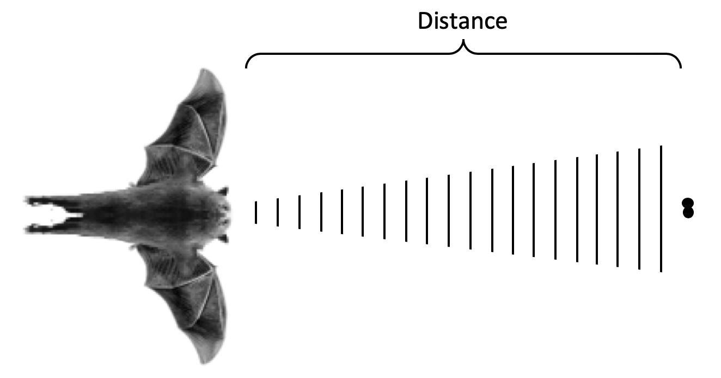

When designing your bat’s behaviour you will need to consider the following issues:

* Eating insects gives you energy (the bigger the insect, the more energy)
* Flying around gradually reduces your energy (faster you fly, the faster the energy decreases)
* When you run low on energy you can only fly at a slow “crawling” pace – so be careful !

IMPORTANT: Your task is to alter your bat file to change its behaviour - you should NOT change any of the other files in the Processing project to achieve your objective.

**Task 3**

Once you have a bat that you think functions well, find another group who have also completed their bat. Copy *your* bat file into *their* WorldOfBats project folder. When you run the WorldOfBats program, it will detect ALL bats in the folder and add them to WorldOfBats. Run the two bats against each other to see which is the most efficient insect hunter !

(Pro Tip: If you press the tab key on the keyboard you will see the current insect score for each bat)